35.44: First find out what fraction the 0.159 ms time lag is of the period.
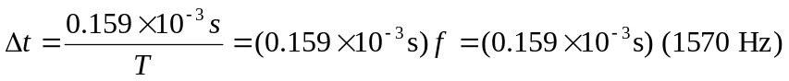
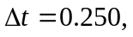so the speakers are 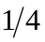 period out of phase. Let A be ahead of B in phase.

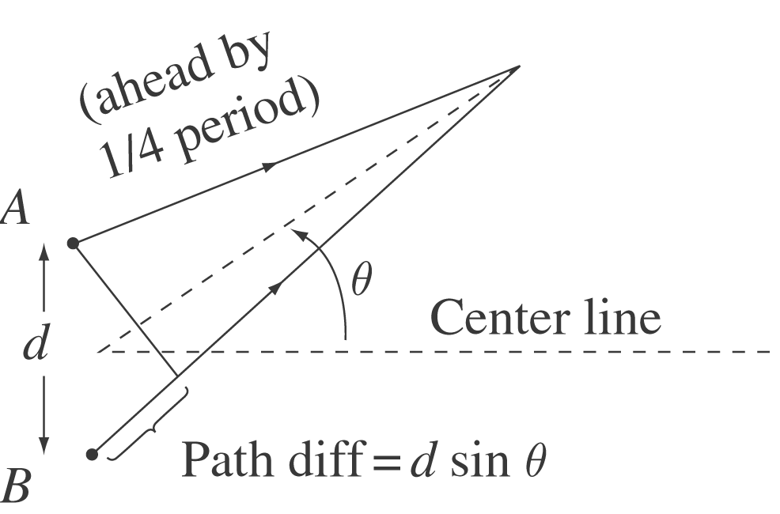

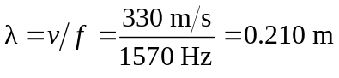
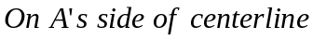: Since A is ahead by period, the path difference must retard B’s phase enough so the waves are in phase.
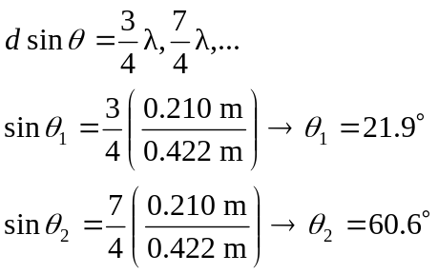
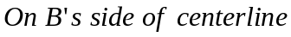: The path difference must now retard A’s sound by 